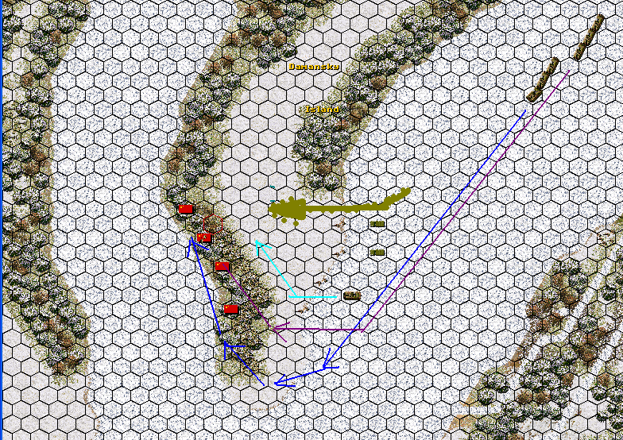

Planning:
1) To bring formation D (1 BTR-60) 2 or 3 hexes to the west and try to spot any of the defending Chinese.
2) Bring formations F & G to the Southern tip of the island and do a “roll up” of the Objective Hexes from South to North with the three “maneuver elements” D, F & G in close coordination. Approximate Russian axes of advance sketched as blue, light blue and purple lines on the map (actually the purple line should be moved a hex or two towards the East, closer to the light blue line).
Main concern: Anti-Tank capabilities of the opposing force.
Secondary (?) concern: Artillery.

Implementation:
Started to probe westwards with D and two of the “retreating” scouts. F & G start movement towards the south tip of the island. Until they reached their destination I had lost two of the scouts (fragile units and correct so) and I had a visual on two opposing sections. The D BTR starts machine-gunning the closest Chinese section. Mortars start incoming. As I have not taken any AT fire and due to the presence of mortars I decide to keep the infantry loaded on the APCs and bring them to a two hex distance from the opposing line of defense (the two hex distance in order to avoid any grenades hitting the APCs). My intention was to use the APCs to suppress and reduce the Chinese infantry and then unload my infantry to “mop up” and advance towards the north (the APCs in close support). If mortars hit them they’ll probably be hitting the Chinese too.
All was going well, two flags were taken and the Chinese infantry was dealt with - no problem. It is then when I decided to move a BTR loaded with an inf+RPG section towards the 3rd flag from the western approaches (shore) and BHAM! what do you know ?! They had an AT capability after all! ☺ This loss was enough to cost me a decisive victory. Should have stuck to the original plan!!!!

Comments:
1. Designing the end game.
Most players regard only a decisive victory as a “real” victory over the AI. And in my experience it is the casualties you take rather then those you inflict that deprive you of a decisive victory. You can try to control the easiness or not of a decisive victory. For example, assume an “end game situation” where the Chinese have lost 90% of their force, the Soviets 10% and have taken all the Victory hexes. With the current value of flags (210) this situation would result in a Soviet Decisive victory but if the total value of the flags is set below 100 it would result in a marginal victory (see following table). So the question is what do you, as a designer, think should constitute a Decisive Victory in this scenario?

 | Force Value | % Losses | Value of Losses | Value of Objectives Held | Rus/Chin Victory Ratio
Chinese | 404 | 90 | 363.6 | 0 | 9.9
Russian | 578 | 10 | 57.8 | 210 | 9.9
Chinese | 404 | 90 | 363.6 | 0 | 9.0
Russian | 578 | 10 | 57.8 | 155 | 9.0
Chinese | 404 | 90 | 363.6 | 0 | 8.0
Russian | 578 | 10 | 57.8 | 100 | 8.0

You might find this post and the attached material interesting:
http://www.gamesquad.com/forums/showpost.php?p=525660&postcount=2

2. Making the “extraction” of the Alarm Group count.
What is the incentive, for the player, to withdraw the Alarm Group (assuming you want it to withdraw)? As things are at present, it is rather limited. You might consider increasing the cost of the scout units of the Alarm Group, ie making them more valuable and at the same time limiting their ammo (considered they have already been engaged). The limited ammo may also discourage the player to actively employ them at the beginning of the battle (if, again, this is something you want to avoid). I would also consider putting them under mortar fire from turn “0”.

3. The Chinese Defense Line.
It is a line literally! No depth. I consider this as a characteristic of the scenario. In real life you don’t get to choose the best position (well not always!). What may need some reshuffling is the Northern flank where you have the HQ, mortar section and the RCL Tm together with actually one infantry section to support them. Essentially the flank is uncovered. Now with the plan I had (advancing from south to north) this was not much of a problem but if a player chooses another line of advance (such as the olive colored one on the map) then he might start the battle by taking out all these essential elements in his first contact! I would avoid having these three units together and/or consider at least an additional infantry section to support them.

4. Field of view of the RCL Tm.
I would “tweak” the map a bit to give this unit a more expanded field of view as it is probably this unit that will “decide” the human player’s level of victory.

5. Scenario Duration and Replayability.
This is probably one of the most frequently used methods of adjusting difficulty for the human player. Giving the human player “less” turns or not is a fundamental design choice. In my opinion, limited scenario duration is a “trick” that may increase the “replayability” and difficulty of a scenario but in many cases is abused by scenario designers. Anyway this is a factor you must (re)consider.
And there is the question of replayability. A scenario is considered “worthy” if players play it more than once. Some people replay a scenario until they get a decisive victory, others do so because they enjoy the scenario. For me the “enjoyment” factor is crucial. But part of the enjoyment of the SP series is the concealment of the opposing forces. Take for example this scenario. It was the RCL Tm that “made” the game. Replaying this short scenario with the knowledge of the position of this unit … well does not seem so interesting. What I am trying to say is that these short scenarios must (?) be designed with the “first game” in mind. Provide the player with the information he needs to formulate a good plan within the limits you impose as a designer. For example if you limit game duration provide the player information about artillery or other capabilities of the opposing force.

Short, sweet, based on history and an “unknown” conflict. Map is good!
I like it.
Keep them coming!

