STUDENT NOTES
DESCRIBE THE INFANTRY (8.1.1)

Introduction

The aim of this lesson is to describe the Infantry in the context of being one of the three Combat Arms. The lesson starts by looking at the Spectrum of Conflict and relating the roles of the Infantry to the continuum that exists between peace and war. Next, we talk about the four main types of Infantry battalion, Armoured Infantry (AI), Mechanised Infantry, Air Assault and Light, and how Infantry battalions are structured to carry out their role. This is followed by equipment and capabilities, which are specific to the various types of battalion.
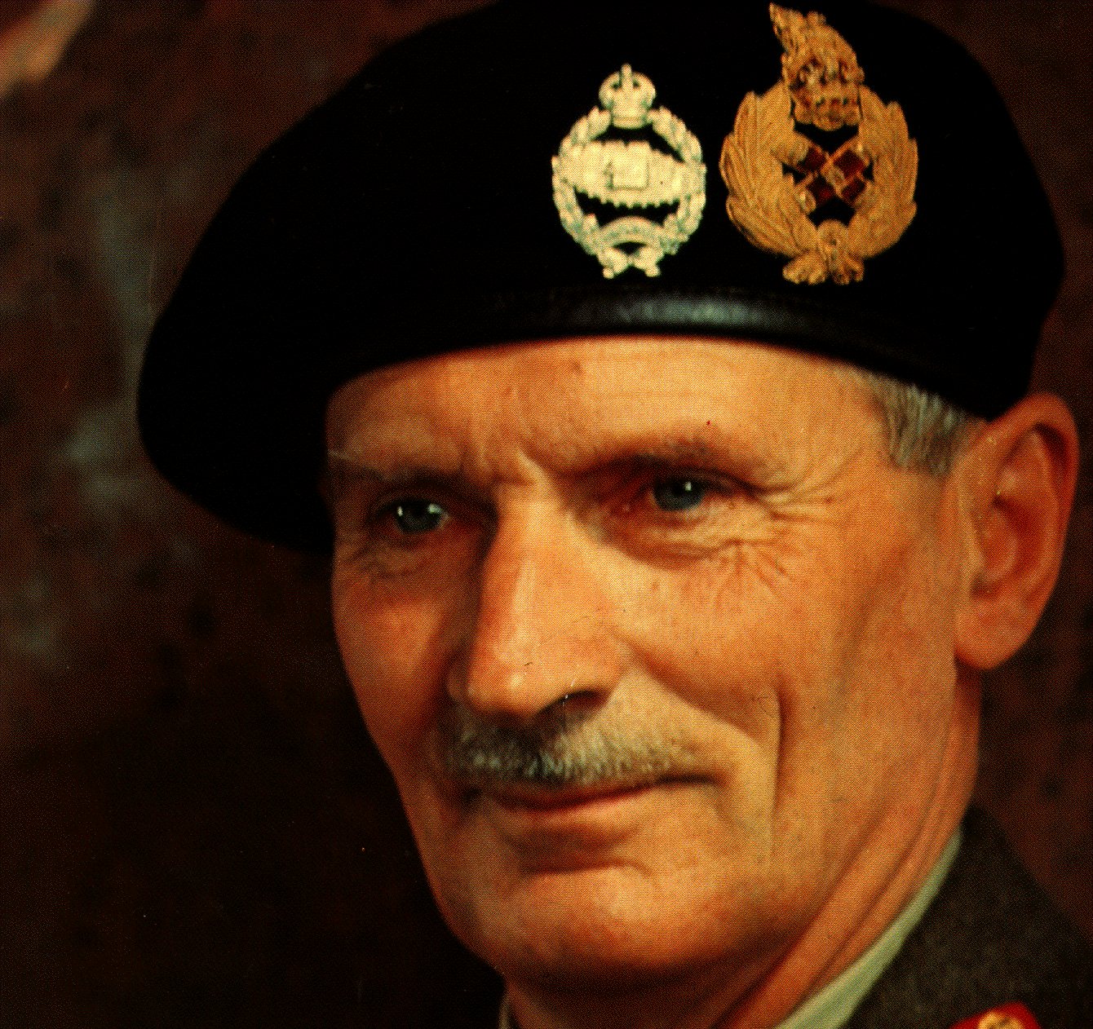
The last part of the lesson covers the changes that are expected for the future. Arguably the most important of these is cadreisation where high readiness battalions are twinned and the one that is deployed is reinforced with soldiers and equipment from the other formally twinned battalion.

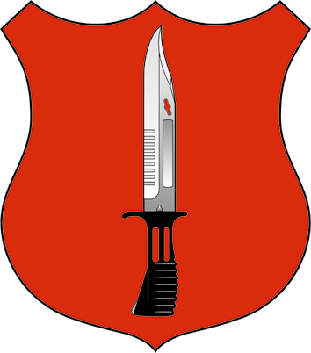

Figure 1. Infantry Shield Figure 2. Infantry Map symbol Figure 3. Montgomery

Learning Outcome
By the end of the lesson, you should be able to describe the Infantry. The lesson covers the following topics:
- The Role of the Infantry.
- The Structure of the Infantry.
- The Capabilities of the Infantry.

Activity 1 (2 Minutes)
Drawing on your experience, think about the sort of roles and tasks that you would expect the Infantry to carry out. When considering this, think about the different types of Infantry that you have come across in your service to date.
Discussion
You may have considered things like:
Closing with and killing the enemy
Holding ground
Supporting the Civil Authorities
Peacekeeping
Counter Insurgency Operations.

Role of the Infantry

The Infantry is one of the three Combat Arms, its mission is:
Mission. To preserve its warfighting ethos the Infantry’s mission is “To defeat the enemy through close combat” in the context of a combined arms battle.

The roles that the Infantry may be asked to carry out in support of this mission are many and varied. They range from Military Aid to the Civil Authorities (MACA) in peacetime, through Peace Support Operations in periods of tension to theatre specific operations like jungle warfare or mobile armoured operations in general war. An example of some of their roles is shown against the Spectrum of Conflict in Table 1.

SPECTRUM OF CONFLICT | Peace Conflict Other  than War  Regional General  Conflict War
Roles of the Infantry | Military Activities Other Operations  In Peace  Counter Insurgency Ops  MACA  Internal Security Ops Warfighting
Table 1. Infantry
At one end of the spectrum, the Infantryman must be mentally flexible enough to accept the constraints required for MACA in peacetime whilst at the high intensity end, warfighting, he must combine the skills as a foot soldier with the technical skills required for Armoured warfare. In addition he must carry out these roles across a variety of climates and environments, with increasingly sophisticated and varied equipment. These demands require the Infantry to be versatile, flexible and adaptable.

The modern Infantryman is best deployed as part of an All Arms formation. However, in close country, such as mountains, woods, forests and built up areas, it is the Infantryman’s skills that are primarily required. Infantry battalions are not now trained for specific theatres, but use training in a specific theatre to enhance their overall effectiveness.
Every Infantryman will undertake training in the jungle. It is intended to be the foundation of the training of all Infantry battalions. This enables optimum mental and physical preparation. Training will involve a minimum of 4 weeks living and operating in the jungle. The aim of this jungle training is to assist in producing highly adaptive and rugged battalions. It does not produce a battalion skilled in advanced, collective jungle warfare techniques.
It is this versatility and adaptability that is the strength of the Infantry. The Infantry has the ability to move at a marching pace across all types of terrain in all weathers, striking at unexpected times - this is what Liddell-Hart called “loco-mobility”.

Battlefield Tasks

The purpose of the infantry, of closing with and engaging the enemy has not really changed. However, it is the battlefield on which it fights that is hugely different.

British Army doctrine encourages us to focus principally on the enemy and the effect we wish to achieve. The aim may be as Sun Tzu said, “to defeat the enemy without loss”, but at some point someone has to be committed to closing with him, whether it be to find him, fix him or strike him.

Task 1
Assume a major role in offensive Operations in the all arms environment. With Warrior, the Armoured Infantry keeps pace with armour, has excellent protection and impressive firepower. It fully contributes to the All Arms battle and can take the lead - mounted or dismounted - where circumstances direct.

Task 2
Participate in the anti-armour battle. The infantry’s ability to contribute to the anti-armour battle is based not only upon its anti-tank platoons equipped with MILAN, but is derived from the combined effect of its 30 mm Rarden cannons, its 81 mm mortars, its 94 mm LAW and, of course, the Infantryman himself. An air assault battalion has additional MILAN and can be grouped with anti-tank helicopters into Avn BGs.

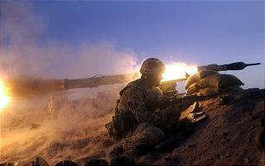

Shaping the battlefield by holding ground. This is the role that no other arm can carry out and it has, in terms of our doctrine, a major part to play in both fixing and striking the enemy. This can be done in two ways. Firstly, holding ground that constitutes an enemy’s objective denies him his goal and secondly, it deprives him of his freedom of action thereby denying him routes or avenues of approach to his objective. In terms of striking, the holding of ground physically shapes the battlefield by acting as a pivot for the armour, to ensure that the enemy is destroyed in the place of our own choosing. All types of infantry are suitable for this task.

Task 3
Provision of a firm defensive framework in depth. This might seem to be similar to holding ground; there is, however, a fundamental difference. By holding ground you aim to physically deny a piece of ground to the enemy. A defensive framework in depth focuses on the destruction of the enemy. The framework provides the means to achieve that by channeling him into areas of our choosing. Implicit in this task is the acceptance of penetration and thus the ground over which the operation is taking place is not in itself important to the plan.

The protection of critical assets. In all military operations it is vital to protect a variety of important facilities; be they reserved demolitions, logistic installations, headquarters or airfields. Protection is also an essential element of rear operations and is a task frequently given to light battalions.

Structure

Infantry battalions are categorized by type. This affects how they are equipped and their resulting capability. Although there are four types of battalion they are organised into the same structure. Composition by type and the battalion and company organisation are discussed below.

Composition

There are 40 Infantry Battalions. These are organised into four types: Armoured, Mechanised, Air Assault and Light Infantry as follows:

- 9 AI battalions.
- 6 Mech battalions.
- 4 Air Assault battalions.
- 11 Light battalions.

Note + 9 Light (6 NI, 1 Brunei, 2 Cyprus) & 1 Mech at LWTC.

It should be noted that an Infantry battalion will generally change from one type to another every six years. This means that Infantry battalions will have a variety of skills that will be transferred.

Battalion Organisation

Whatever their role, all regular Infantry Battalions (Inf Bn) are currently organised as shown in Figure 4.

Bn HQ

HQ Coy Man Sp Rifle Coy Rifle Coy Rifle Coy

Figure 4. Organisation Schematic-Inf Bn

Company Organisation

The companies are structured differently according to their role in the battalion and are frequently re-arranged depending on the nature of operations.

Headquarter Company
Headquarter Company (HQ Coy) is responsible for providing the command and administrative element of the battalion. It is divided into the departments shown in Figure 5.

HQ Coy

Welfare
Office
Medical
Section
Battalion Headquarters Signal Quartermasters Provost Motor Transport Light Aid Regimental Training Headquarters Platoon Platoon Platoon Staff Platoon Det Admin Det Wing Section

Figure 5. Organisation Schematic-HQ Coy

Activity 2 (2 Minutes)
Now that you have looked at the basic organisation of an Infantry battalion, think about the tasks that the Manoeuvre Support Company carries out. Spend some time writing down some of the tasks that you think it might carry out.
Discussion
Whilst the main tasks for the Anti Tank platoon and the Mortar Platoon may seem obvious at first sight, you may have considered other things like basic surveillance using optics (from the Anti Tank Platoon) as part of a surveillance plan.
You might also have considered the use of the Mortar Platoon as part of an artillery group providing Close Support for operations. When considering the tasks for the Assault Pioneer Platoon you might have considered things like mobility and counter-mobility and there are many things that the Assault Pioneer Platoon can do relating to this subject.

Manoeuvre Support Company
This company contains the battalion’s main firepower assets, and provides the battalion’s integral direct and indirect fire weapons. It is split into platoons for training and administration, but on operations, the company is organised in support of the battalion’s mission:

Man Sp Coy HQ

ATk Pl Mor Pl ISTAR Gp Asslt Pnr Pl

Figure 6. Organisation Schematic-Man Sp Coy
Anti Tank Platoon (A Tk Pl) This is currently equipped with MILAN which is described under capabilities. The platoon is broken down into a HQ and two sections of 6 MILAN. MILAN is to be replaced by JAVELIN.

Mortar Platoon (Mor Pl) The Mor Pl is organised into four sections, three Mortar Sections and one Observation Post (OP) Section. Each mortar section has two detachments with one mortar per detachment. The OP section provides three Mortar Fire Control parties each with two Mortar Fire Controllers (MFC). On operations the MFCs will deploy to the Rifle Coys to direct both mortar and artillery fire. In AI battalions, each mortar is mounted in its own Armoured Personnel Carrier (APC) and each MFC party travels in a Spartan.

Intelligence, Surveillance, Target Acquisition and Reconnaissance (ISTAR) Group On Operations, the ISTAR Group consists of the Reconnaissance Platoon (Recce Pl) and snipers. The Recce Platoon is mounted in Scimitars in an AI battalion or Landrovers in the other battalions. There are three sections, each with two vehicles, and a Pl HQ with two vehicles.

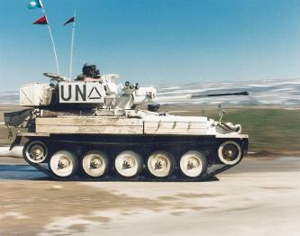
Figure 7. Scimitar
Assault Pioneer Platoon (Asslt Pnr Pl) The Asslt Pnr Pl is available to the BG Commander as a limited integral Mobility and Counter Mobility asset. It is formed as a normal rifle platoon, but will operate in independent sections.

Rifle Companies (Rifle Coy)

The organisation of a Rifle Company is generally the same, regardless of role, however there may be a requirement for the attachment of extra personnel depending on the role and any reconfiguration of the Orbat specific to the nature of Operations.

Rifle Coy HQ

Pl Pl Pl

HQ

Sect Sect Sect MSp Sect

Fire Team Fire Team

Figure 8. Organisation Schematic-Rifle Coy

The Rifle Coy is divided into a Coy HQ and three Platoons. The Coy HQ has a command element, which in an AI battalion is mounted in two WARRIORs (WRs) and in a Mech battalion in one SAXON. Each platoon consists of a headquarters and three rifle sections and a Manoeuvre Support (MSp) Section. Rifle sections are based on 8 riflemen, organised into two 4 man fire teams. The MSp section currently contains two GPMGs. Each section is equipped with 2 x SA80s, two Light Support Weapons, 2 x LMG’s & 2 x UGL’s.

Capabilities

In the next part of the lesson we will look at the roles and capabilities of the types of Infantry Battalion:
Activity 3 (2 Minutes)
1. Now that you have looked at Infantry organisation in general, think about the capabilities and roles that each type of Infantry can carry out. Make some notes about the roles that each type of Infantry shown would be particularly suited to. Review the lesson to get some ideas if you need to:

Armoured Infantry
Mechanised Infantry
Air Assault Infantry
Light Battalions
Table 2.

2. Now think about the Armoured Infantry in more detail. Based on what you have seen so far in this lesson, what problems do think might be caused by the mix of vehicles eg Warrior working along side AFV 432.
Discussion
1. Roles
When looking at the roles, you may have considered those based solely on the equipment available to each type of Infantry. For example, Light Battalions are excellent for fighting in close terrain and in urban areas because they move around mainly on foot once deployed. Air Assault Infantry is good for gaining surprise and being flexible because it can deploy quickly when needed, often at very short notice.
There is no definitive list of specific roles against each type of Infantry.
The main point to remember is that the Infantry is a versatile and flexible Arm. Without it, wars cannot be won.
2. Vehicle Mix
Vehicle mix in the Armoured Infantry can often cause problems. Some of the things you may have considered are problems such as matching speed of vehicles in offensive operations (eg Warrior and the AFV 432) and maintenance.
Maintenance is a particular issue and you should be able to draw your own conclusions as to what impact this has on the REME as the lesson unfolds.
In an ideal world, all the vehicles in a Battle Group would be of the same type. Until they are, you need to be aware of the impact that this mix has on basic operations.
Now read on and compare what you have written with the information below.
The capabilities, including key strengths and weaknesses, are as follows:

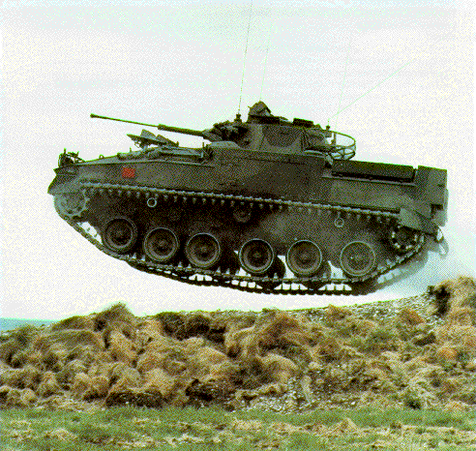
Figure 9. Flying Warrior

Armoured Infantry
The AI battalion, has at least 45 WRs in the battalion and 14 WR’s per rifle coy. It possesses good tactical mobility, good firepower from a 30 mm Rarden cannon, a chain gun and reasonable battle-field protection. The WR is an excellent vehicle but of course its effectiveness is much enhanced by close integration with Armour.

The AI battalion does have three principal limitations:

- Despite the planned allocation of WR to Milan platoons there is no capability to fire anti-armour weapons from within the vehicle.

It has no integral low level air defence.

AI battalions are equipped with a mixed fleet of AFV 432s, WRs and Scimitars. Scimitar is fitted with the same 30 mm Rarden Cannon as the Warrior, but has not yet got a universally fitted vehicle mounted TI capability. AFV 432s, like Scimitar, cannot match the mobility or protection of WR either on road or across country. The commander is therefore left with a difficult choice of either moving at the speed of the slowest vehicles in order to maintain balance, or moving at the speed of his fastest and most combat effective vehicles.

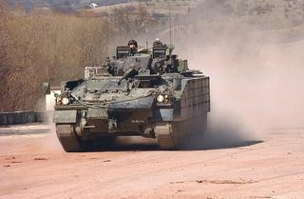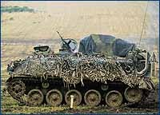

Figure 10. Warrior Figure 11. AFV 432

Mechanised Infantry
A Mech battalion is equipped with SAXON, and is organised in almost exactly the same way as the AI battalion. SAXON is a Wheeled APC, which improves the effectiveness of Rifle Coys by giving them limited protection and mobility under armour.

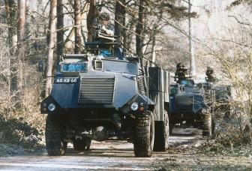
Figure 12. Saxon
The limitations of a Mech battalion are its limited Combat Power, the lack of protection for its mortar platoon, currently in RB44s, and its soft skinned vehicles.

Air Assault Infantry
There are 4 Air Assault Battalions organised for movement by helicopters. This gives them good operational but poor tactical mobility.
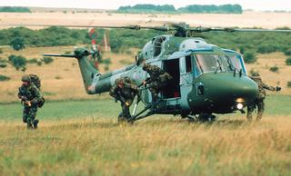

Figure 13. Lynx

The Recce Platoon is mounted in airportable Landrovers (LRs). It should be noted that the whole battalion can move in its own integral soft-skinned transport when required. This consists of LRs, 1, 4 and 8 tonne vehicles.

Light Battalions
Light battalions are either transported in soft skinned vehicles (LRs and ‘trucks’), helicopters or move on foot. All light battalions have an excellent ground holding or protective capability and they can also be used most effectively in Offensive Operations in close terrain and built up areas. Their key limitations are limited Combat Power and limited tactical mobility.

We structure and equip battalions for their anticipated role, attempting to match limited resources on one hand with the requirement to maintain a wide range of capabilities on the other. A Light battalion, for example, has more immediate strategic mobility than an AI or Mech battalion.
Even in an armoured environment, there is a role for light battalions, as additional infantry. They are used for a myriad of tasks - from defending built up areas, key points or wooded areas to guarding Prisoners of War (PWs), as demonstrated in the Gulf War. The utility of light battalions has also been shown during the advance into Kosovo, where light battalions from the old 5 Airborne Brigade spearheaded the way for 4 Armoured Brigade.

Activity 4 (2 Minutes)
Carefully, read through the five tasks of the Infantry again. Now make some notes in the table below relating to which types of Infantry are ideally suited for each task. Think about the different organisations and equipments available in each when making your selections.
Task | Types of Infantry
1. Assume a major role in offensive operations in the All Arms environment
2. Participate in the anti-armour battle
3. Shaping the battlefield by holding ground
4. Provision of a firm defensive framework in depth
5. The protection of critical assets
Discussion
Compare what you have written with the details given about the five tasks.
There is no absolute rule to say that a particular type of Infantry

The Future

There are 4 major changes due to take place between now and 2010. These are as follows:

Cadreisation
The War Fighting Establishment of units will be much larger than their peacetime establishments. Infantry battalions will include a fourth rifle company and additional manoeuvre sp elements. This is achieved through cadreisation: that is, high readiness battalions will be reinforced with soldiers and equipment from a separate, formally paired battalion.

It is at Coy level that the largest and most significant changes take place. Starting with the Rifle Pl, shown in Figure 14, you will note the addition of a fourth section. This 5 man group will operate two light or Medium Machine Guns in addition to the platoon’s 51mm Mortar. This section will provide vital homogenous manoeuvre support for the platoon.

The Company Commander’s Manoeuvre Support Platoon will include its own medium
Mortars, MRATGWS, snipers (with Long Range Rifle – LRR) and a coordinating element for his headquarters. Most of this last group has been cadreised, leaving only the company sniper section in place. To provide the manpower for the Assault Pioneer Platoon, the third platoon of the third company has been cadreised. This does not apply in the four Air Assault Battalions who maintain their third platoon in their third company and are additional Assault Pioneer Platoon.

2010 RIFLE COY (x4)

RIFLE PL RIFLE PL LO TEAM MAN SP PL CSS CP CAP
(1+32) (1+32) (1+1) (1+35) SECT Gp (0+2)
(0+4) (3+4)
RIFLE PL PL HQ
(1+32) (1+8)

PL HQ (1+3) 1 X 51mm MOR
NSW SEC ATK SEC SNIPER SEC
(0+12) (0+12) (0+5)
SEC SEC SEC MAN SP SEC 4 X NSW 6 X MRATGW 2 X LRR
(0+8) (0+8) (0+8) (0+5)
2 X GPMG(Lt)

NSW = New Support Weapon (Mortars and Automatic Grenade Launchers (AGLs) are being considered).
Figure 14. Organisation Schematic – Future Rifle Coy

Manoeuvre Sp Elements
Greater emphasis is to be placed upon manning crew served weapons and the capabilities to enable manoeuvre. Manoeuvre support elements are to be embedded in all levels of the battalion. Each coy will be established for its own Anti-Tank and mortars and in each rifle platoon there will be an additional manoeuvre sp element consisting of two GPMGs and 4 snipers.

Manoeuvre Sp Coys
In addition to the Manoeuvre Sp elements at rifle coy level, there will also be a Manoeuvre Support Company. It will include a mortar platoon of six 81mm mortars, an anti-tank platoon of 12 firing posts (16 for Air assault battalions), an established assault pioneer platoon and an ISTAR Group, which includes the recce platoon and snipers. All of the elements, will be reinforced, by the paired battalion, in order to achieve Warfighting Establishment.

Man Sp Coy Coy HQ

MRATGW Pl
12 X MRATGW
+
Mor Pl Asslt Pnr Pl ISTAR LRDBE Pl AD Pl
6 x 81mm HQ + 3 Sects Gp (Cannon/AGL?) 6 x Systems

(LR ATK Pl 8 x LRATGW/PGM?)
(6 x 120mm Mor?) Recce
Pl
+
Snipers

LRDBE = Long Range Direct Battlefield Engagement

PGM = Precision Guided Munitions.
Figure 15. Organisation Schematic – Future Man SpCoy

Battalion Headquarters
When deployed on Operations, there will be two identical main headquarters, known as Main Alpha and Main Bravo, Alpha will be run by the BG Warfare Officer (OC Manoeuvre Support Company). He will be responsible for planning and fighting the current battle. Main Bravo will provide a similar HQ for the 2IC. This will allow him to both operate as a true alternative commander and carry out his normal BG functions.

Equipment Improvements

The 430 vehicle series will remain in service for specialized roles such as Mortars, but may receive an update to components. The Future Rapid Effect System (FRES) will replace SAXON and deliver a medium armoured vehicle. BOWMAN tactical Communications System comes in to service in July 03. This system replaces CLANSMAN and will significantly alter the way the Army conducts its business.

Bibliography:
SOHB.
DINF.
Art of War – Sun Tzu.
Hart, B. (1944). Thoughts on War, Faber and Faber, London.

Suggested Further Reading:

The Infantryman.
British Army Review.
British Army Training Review.

